GOVOS
MASTER PROJECT BLUEPRINT
Administrative • Product • Workflow • Architecture • Security • Implementation

The entire GovOS concept on one page — expanded in the following pages.
Use of this edition: this is a visual planning and explanation document. It preserves the source concept while distinguishing source-derived decisions from recommendations and validation items.

1. Executive Overview
GovOS is a government operational workflow and visibility platform centered on citizen/public issues, departmental execution, SLA management, verified outcomes, auditability, tenant isolation and leadership monitoring.
- Every work item should have an accountable owner.
- Time-bound execution is represented through SLA monitoring and escalation.
- Completion and verification are separate events.
- Leadership manages exceptions and outcomes rather than individual records.

2. GovOS Vision
The target is a traceable government work lifecycle: need → case → ownership → execution → verification → outcome → management insight.

3. Problem Statement
GovOS addresses fragmented operational visibility, unclear ownership, weak cross-department coordination, passive SLA reporting and the risk of treating reported completion as verified outcome.

4. Operating Model
The operating model is built around single ownership, time-bound execution, verified outcomes, auditability, tenant isolation, exception management, interoperability and phase discipline.

5. Master Workflow
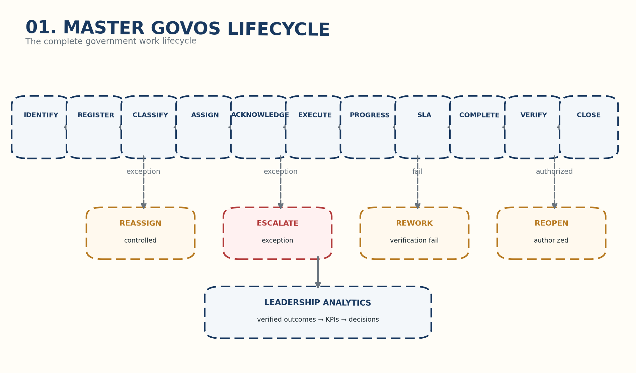
Master lifecycle and controlled exception paths.

6. Citizen / Public Issue Workflow
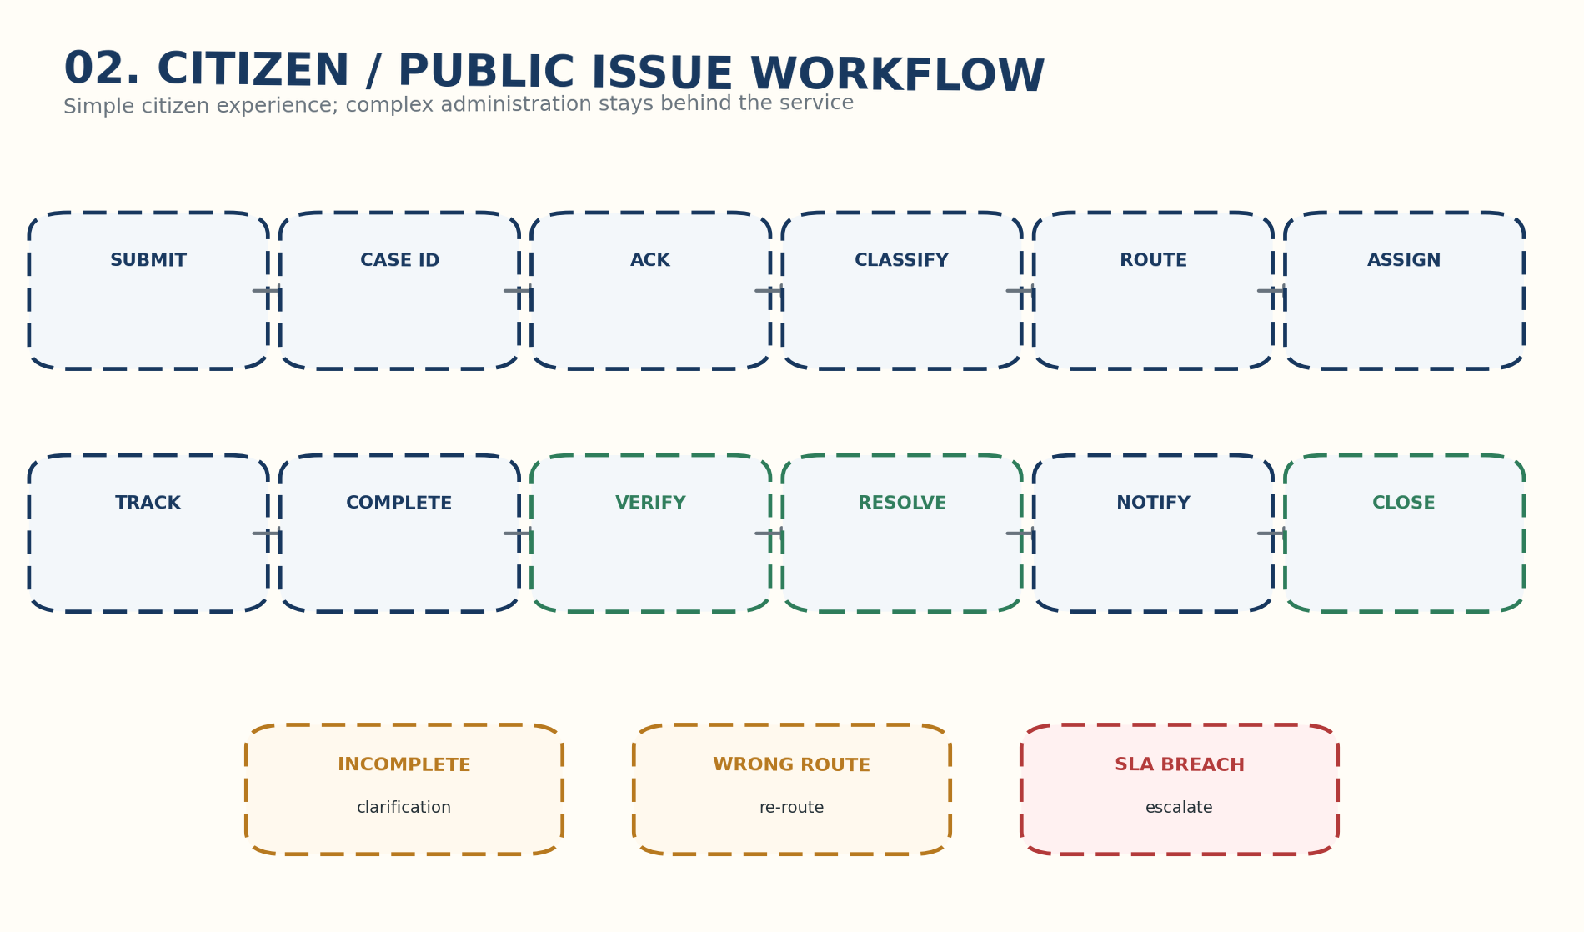
Citizen-facing journey.

7. Department & Officer Workflow
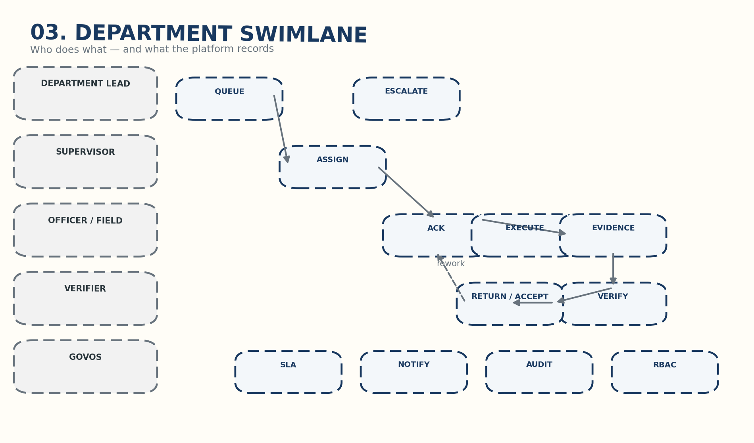
Department swimlane.

8. SLA, Escalation & Exception
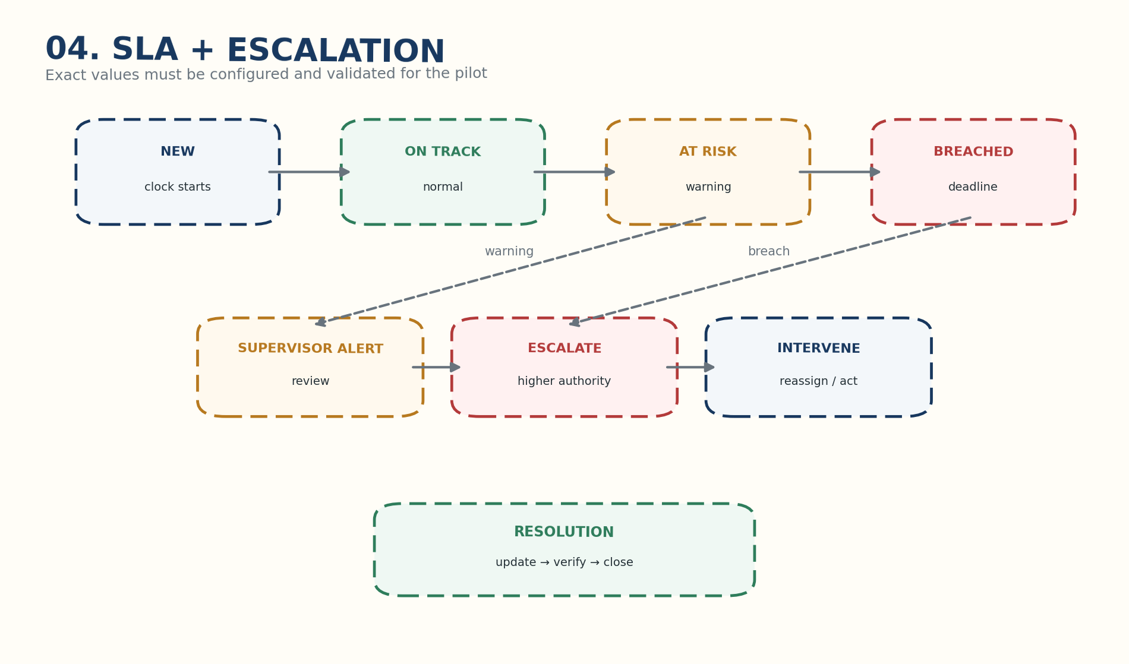
SLA state machine; exact values require pilot validation.

9. Completion & Verification
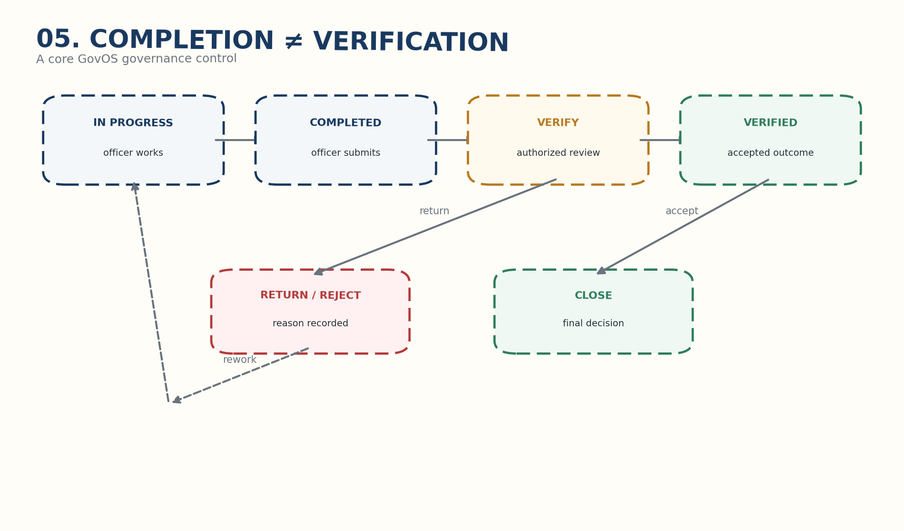
Completion is not verification.

10. Reopen / Rework
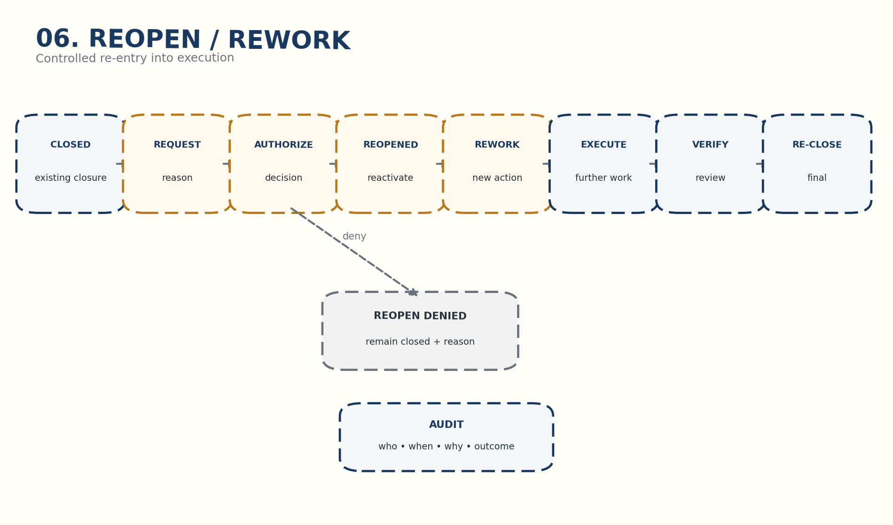
Controlled re-entry after closure.

11. Leadership / Command Centre
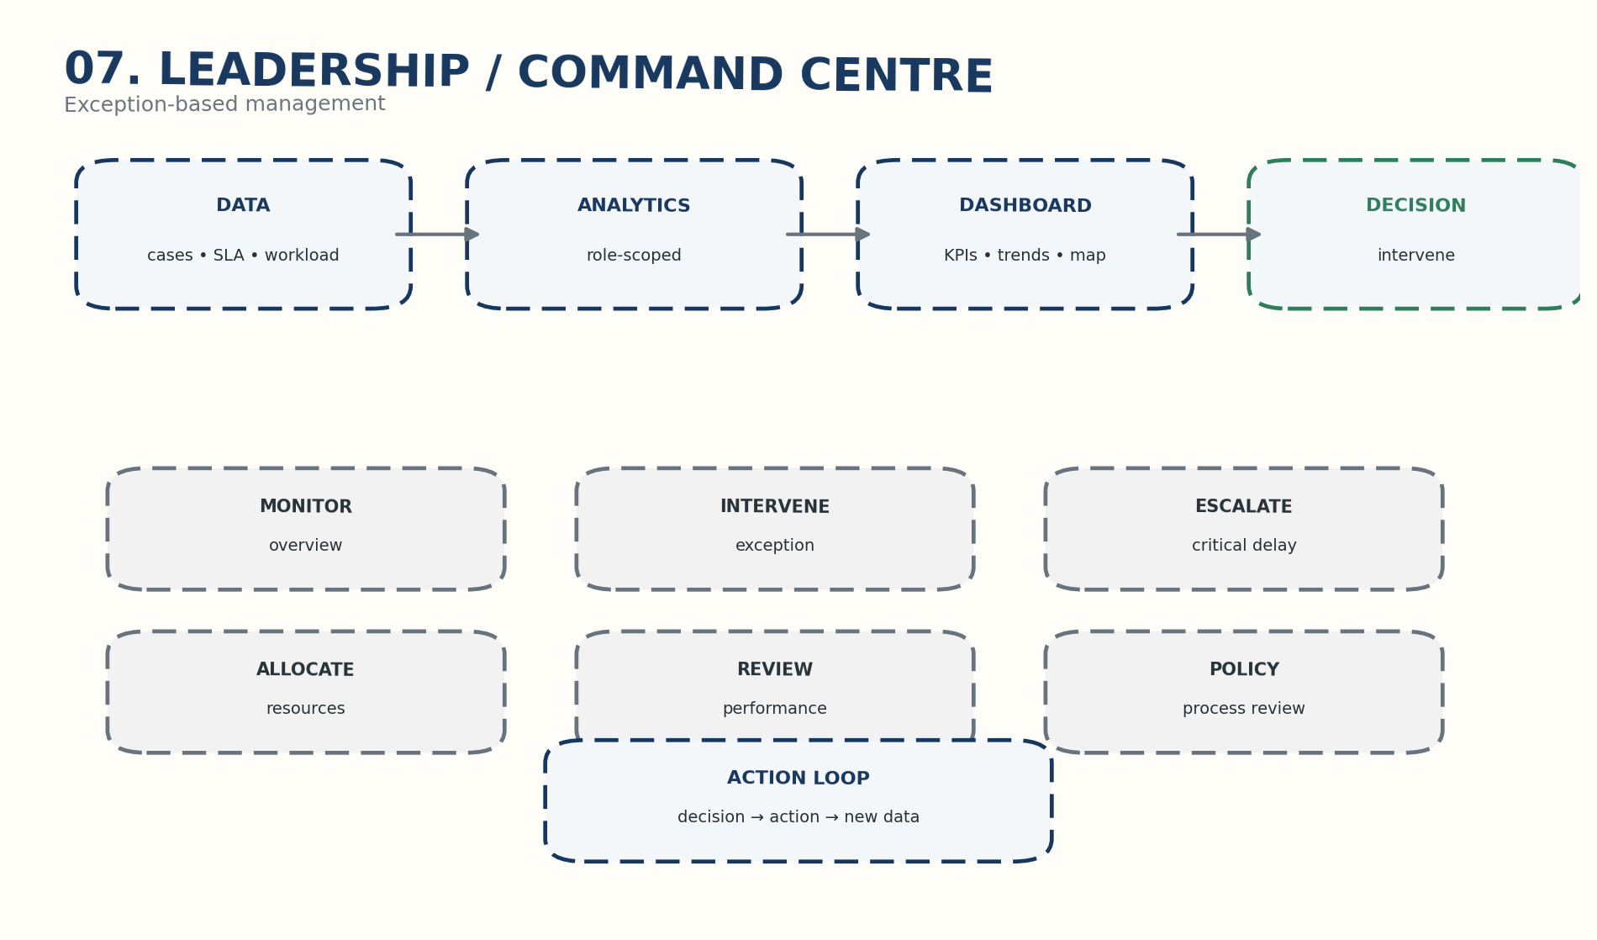
Exception-based leadership model.

12. Role & Responsibility Model
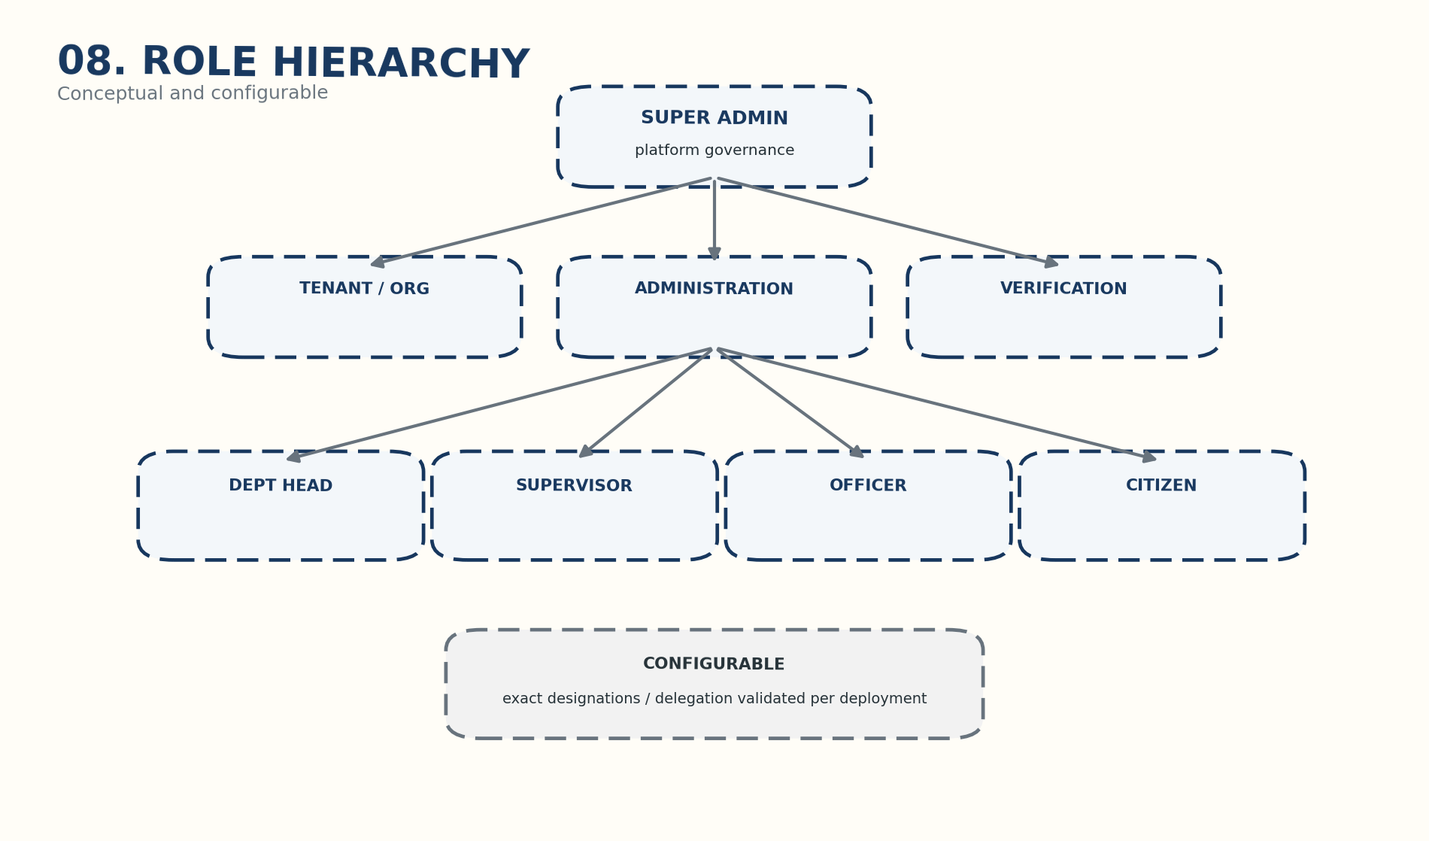
Conceptual hierarchy; exact government designations are deployment-specific.
Persona | Scope | Core responsibility
SUPER_ADMIN | Platform-wide | Platform governance and tenant administration
TENANT ADMIN | Tenant | Users, departments, configuration and oversight
DEPT HEAD | Department | Queue, workload, performance and exceptions
SUPERVISOR | Team / queue | Assignment, review and escalation
OFFICER / FIELD | Assigned work | Execution, progress, evidence and completion
VERIFIER | Authorized scope | Independent completion verification
CITIZEN | Own cases | Submission, tracking, updates and feedback

13. Multi-Tenant Architecture
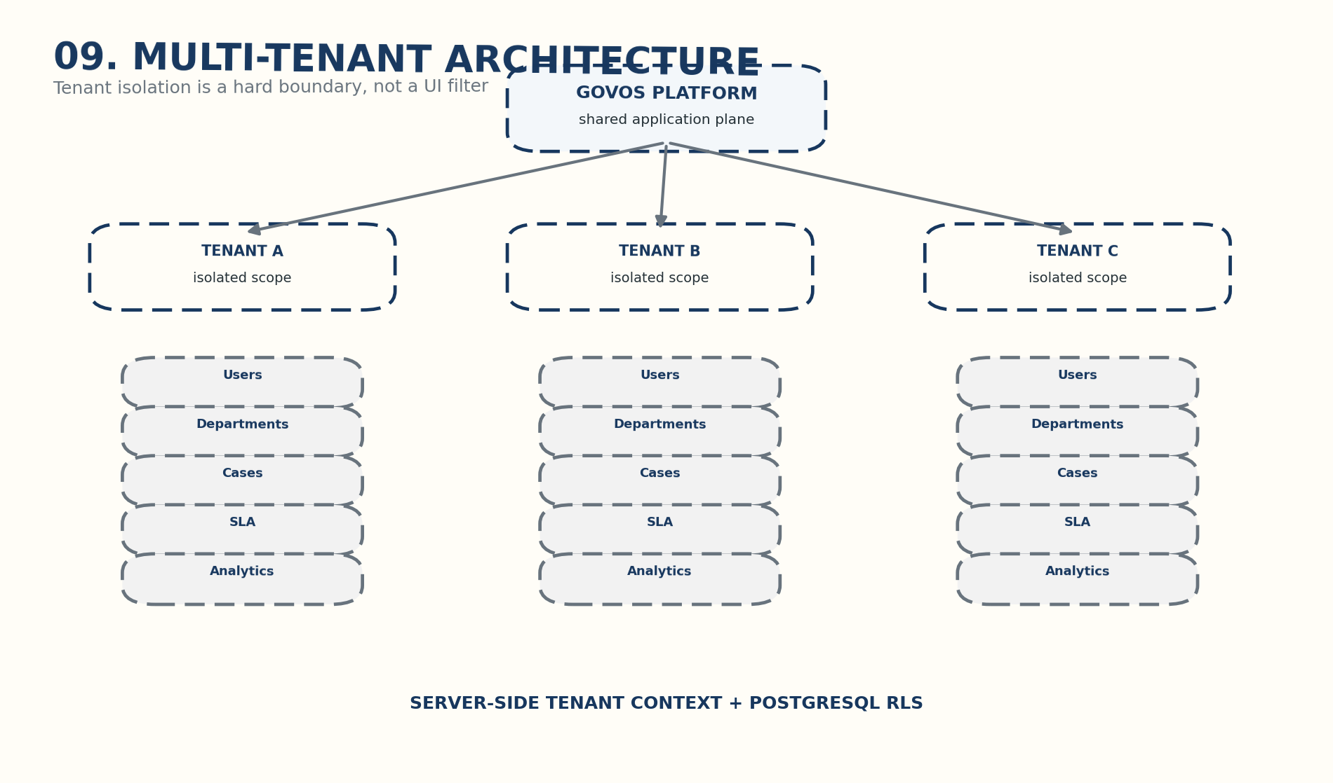
Tenant isolation as a database and application boundary.
- Server-side tenant context must be derived from authenticated identity.
- PostgreSQL RLS should provide a database-level fail-safe.
- Application authorization and database isolation are defense in depth.
- Cross-tenant administrative access must be restricted and auditable.

14. Functional Module Architecture
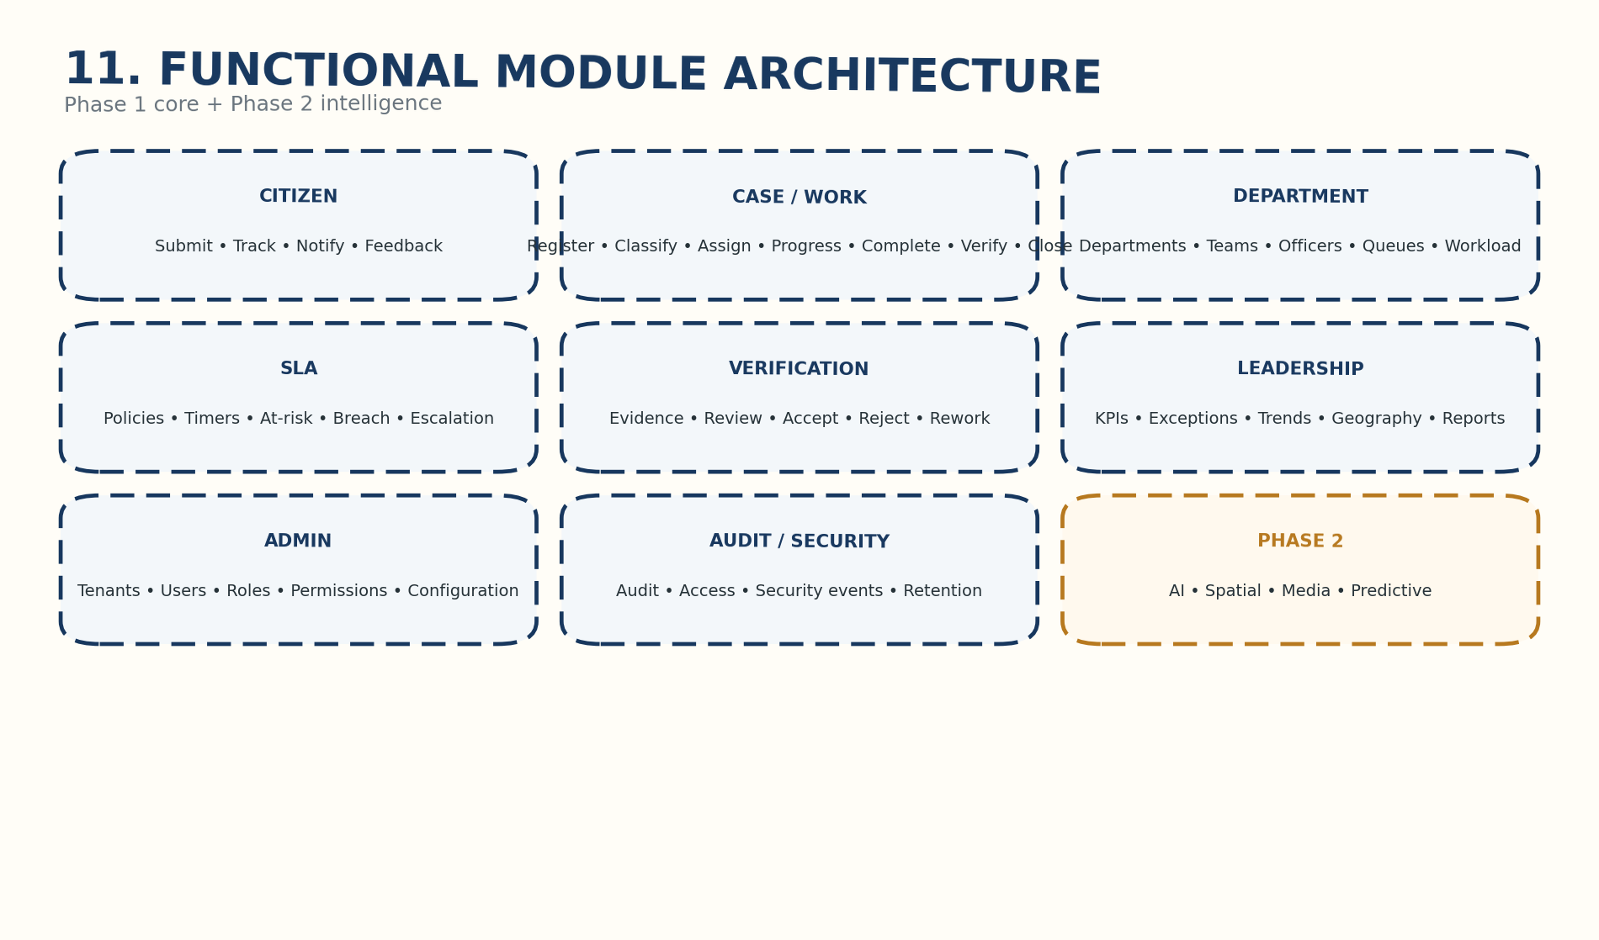
Phase 1 core modules and Phase 2 intelligence boundary.
Module | Phase 1 intent
Citizen Services | Submit, track, notifications, feedback
Case / Work | Registration through closure and reopening
Department | Teams, officers, queues, workload
SLA | Policies, timers, warnings, breach, escalation
Verification | Evidence, review, accept/reject, rework
Leadership | KPIs, exceptions, trends, geography, reports
Administration | Tenants, users, roles, permissions, configuration
Audit / Security | Audit, access, security events, retention
Phase 2 | AI, spatial, media and predictive intelligence

15. Technical Architecture
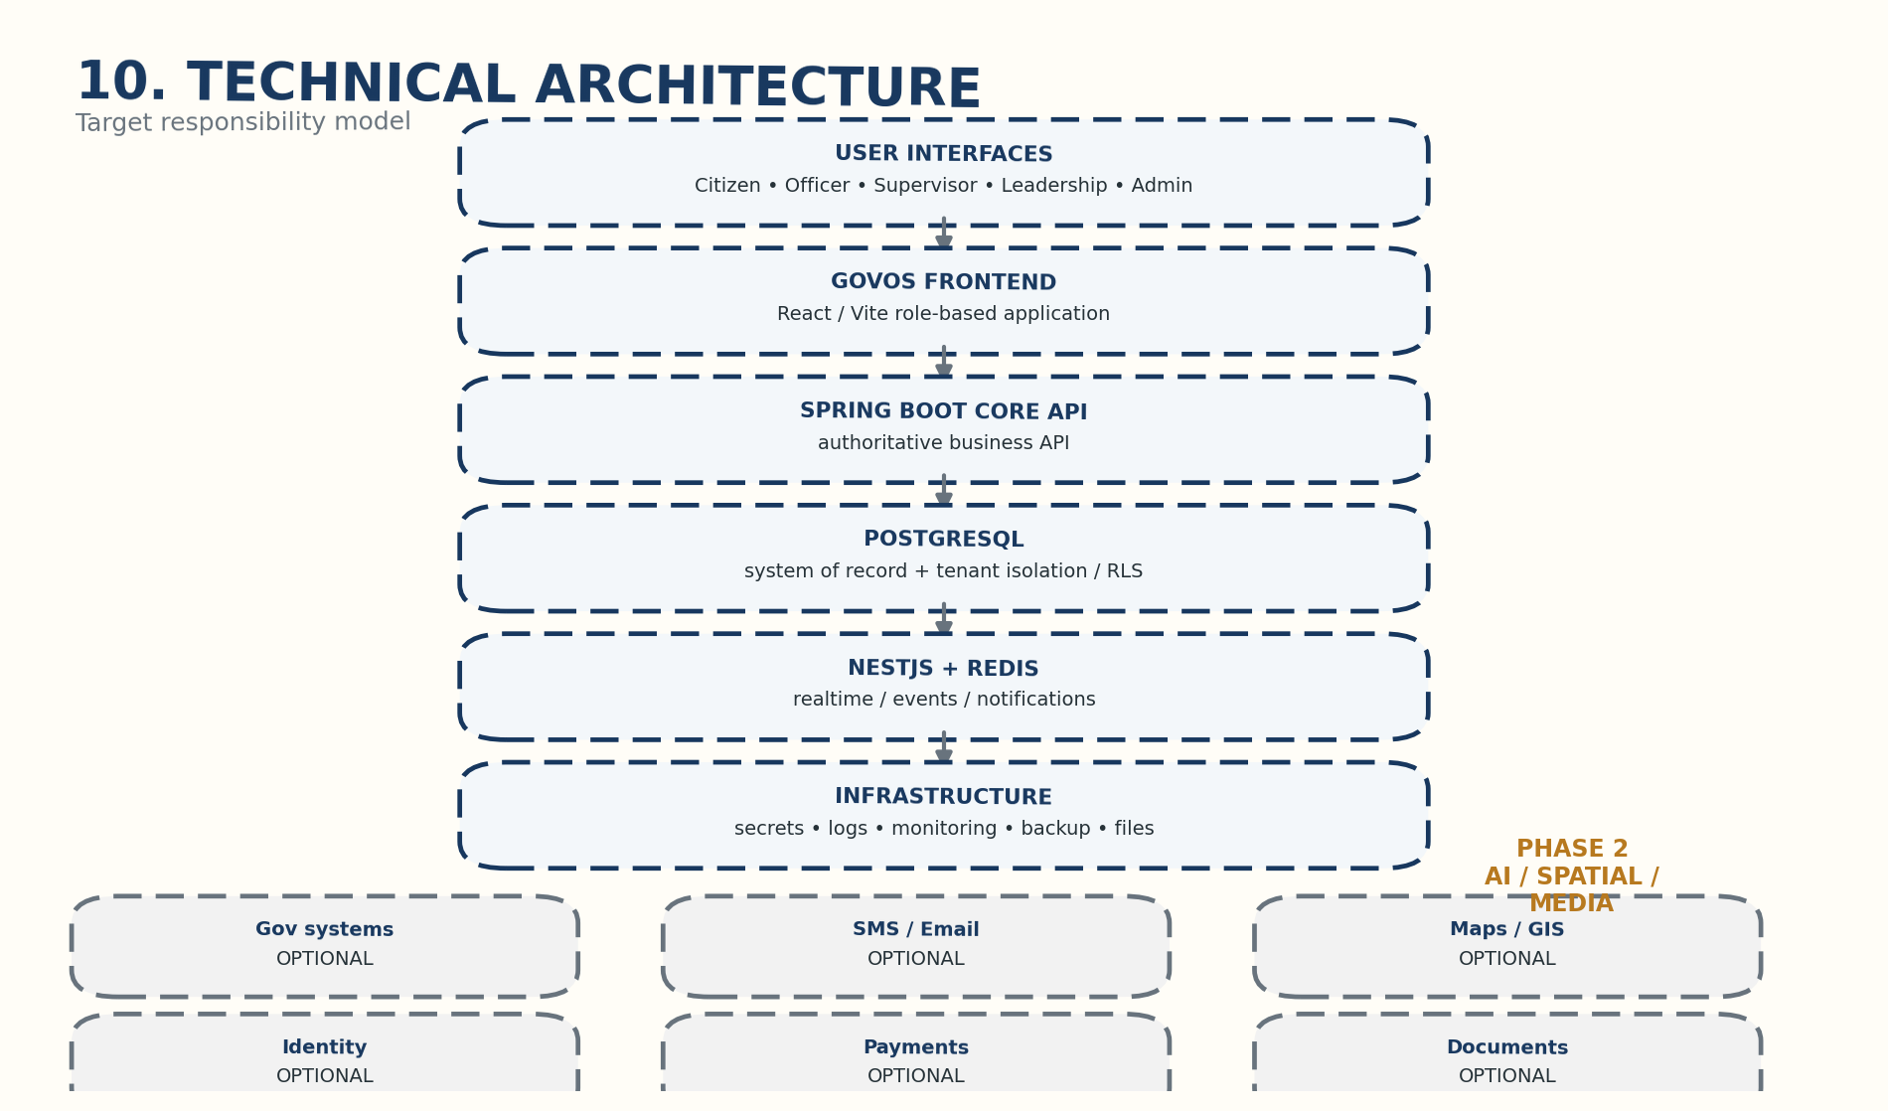
Target responsibility model.
Component | Authoritative responsibility
GovOS Frontend | Presentation and role-based interaction
Spring Boot Core API | Authoritative business rules and APIs
PostgreSQL | System of record and tenant isolation/RLS
NestJS + Redis | Realtime/events/notification event path
Infrastructure | Secrets, logging, monitoring, backup, storage
AI / Spatial | Phase 2 intelligence boundary
Architectural rule: avoid competing business authorities. The current Express backend is a migration fallback, not a second permanent source of business truth.

16. Case / Work Item Lifecycle
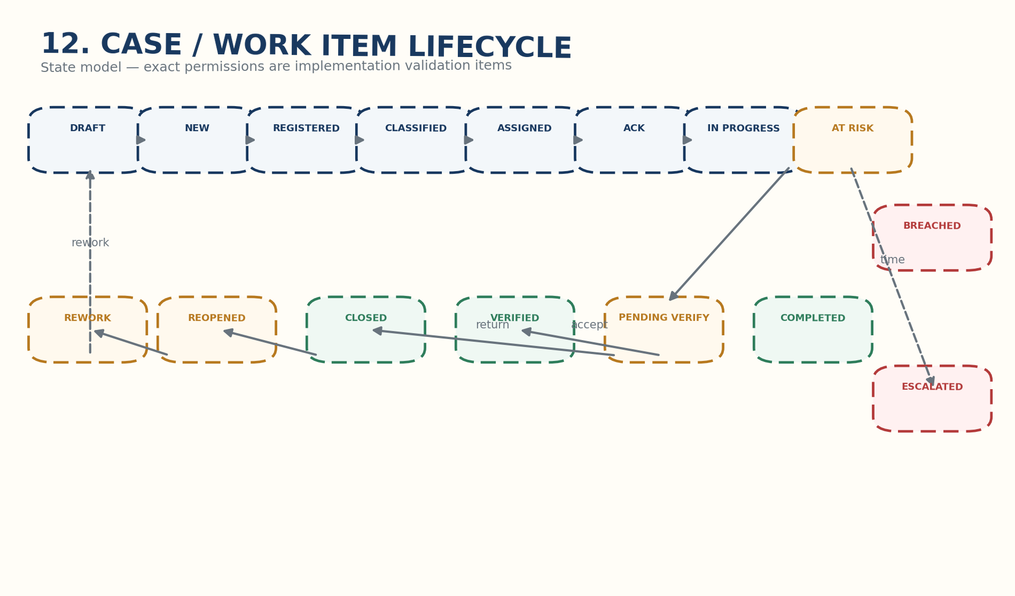
Recommended state model; exact transition permissions require implementation validation.
Transition | Typical initiator | Control
Assignment / reassignment | Supervisor / admin | Scope + audit
Progress / completion | Officer | Assignment scope + audit
At-risk / breach | System | Background worker + audit
Verification | Verifier | Verification authority
Rework | Verifier / supervisor | Reason + new execution
Reopen | Authorized actor | Reason + authorization + audit

17. Conceptual Data Architecture
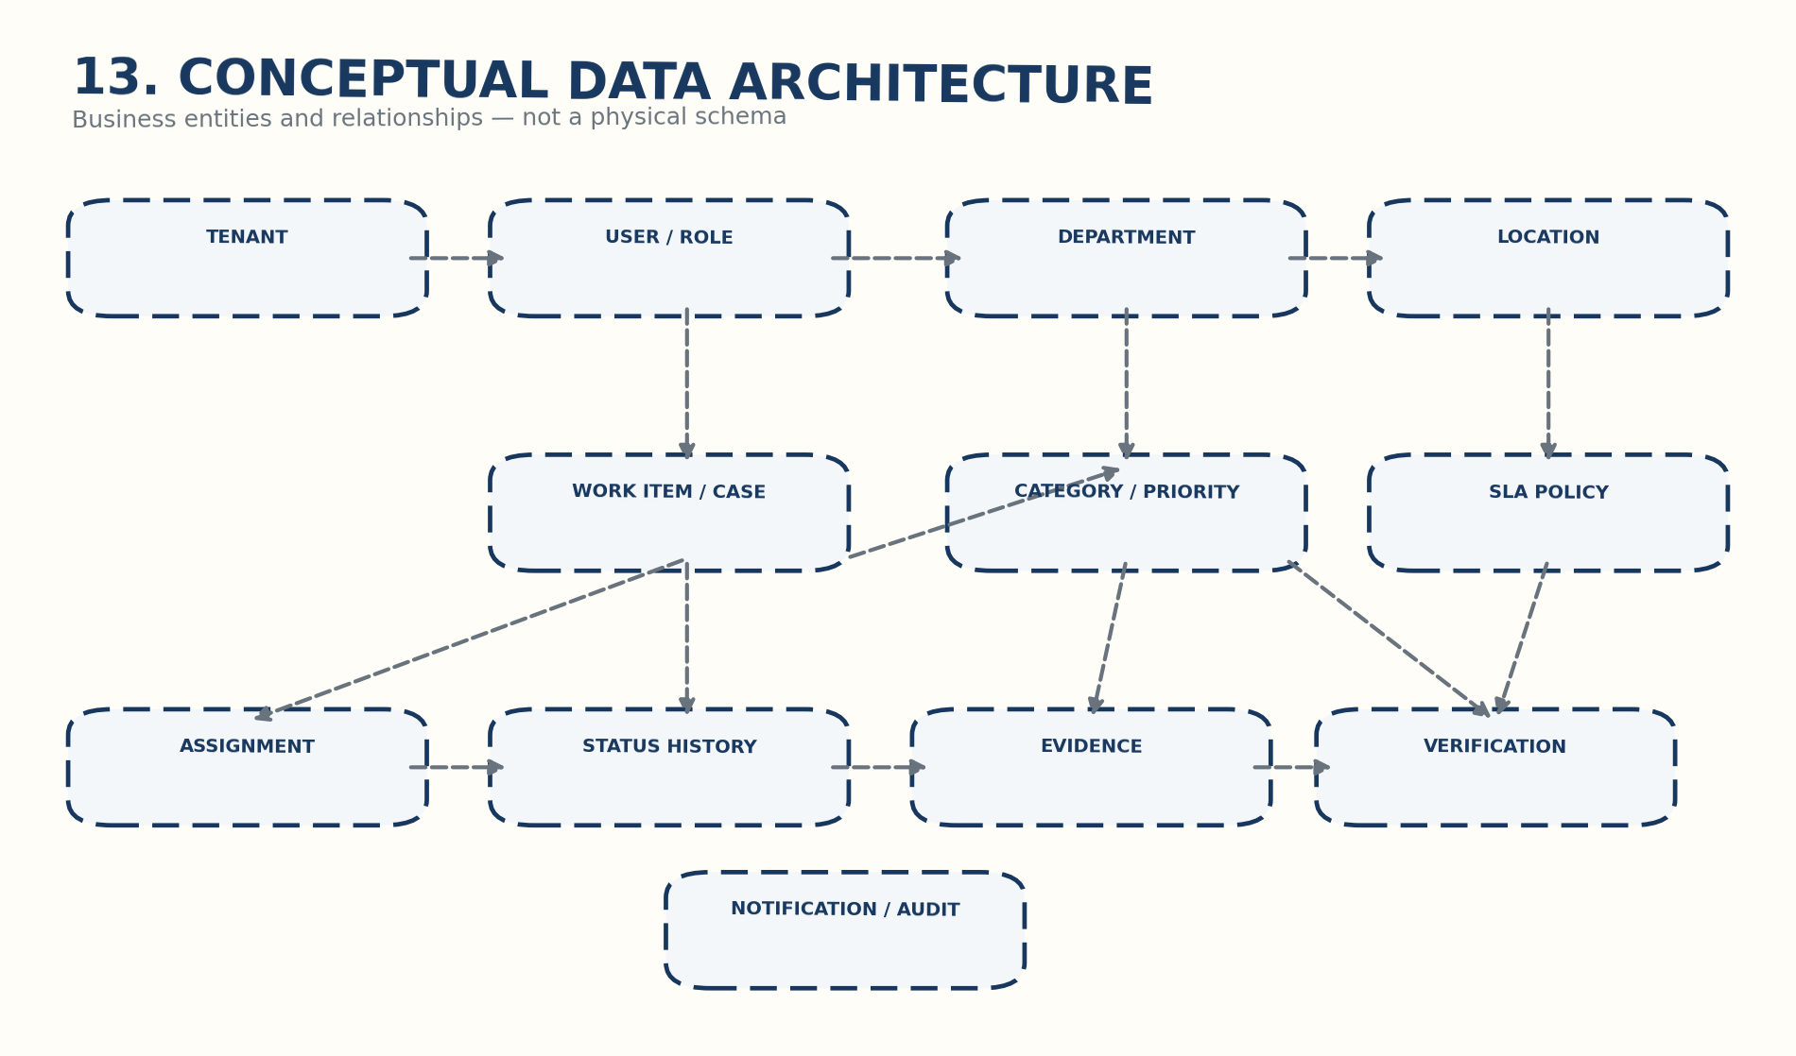
Business entity relationship view, not a physical database schema.
Tenant is the isolation root. Work Item / Case is the central operational object. Assignment, status history, SLA, evidence, verification, notification and audit records preserve lifecycle traceability.

18. Audit Architecture
Recommended chain: USER ACTION → AUTHENTICATION → AUTHORIZATION → BUSINESS ACTION → AUDIT EVENT → TIMESTAMP → ACTOR → OBJECT / CASE → OLD VALUE / NEW VALUE where applicable.
Audit element | Purpose
Actor | Who acted
Timestamp | When
Tenant | Administrative boundary
Action | What operation
Object / Case | What was affected
Before / After | What changed
Outcome | Success / failure / exception

19. Security Architecture
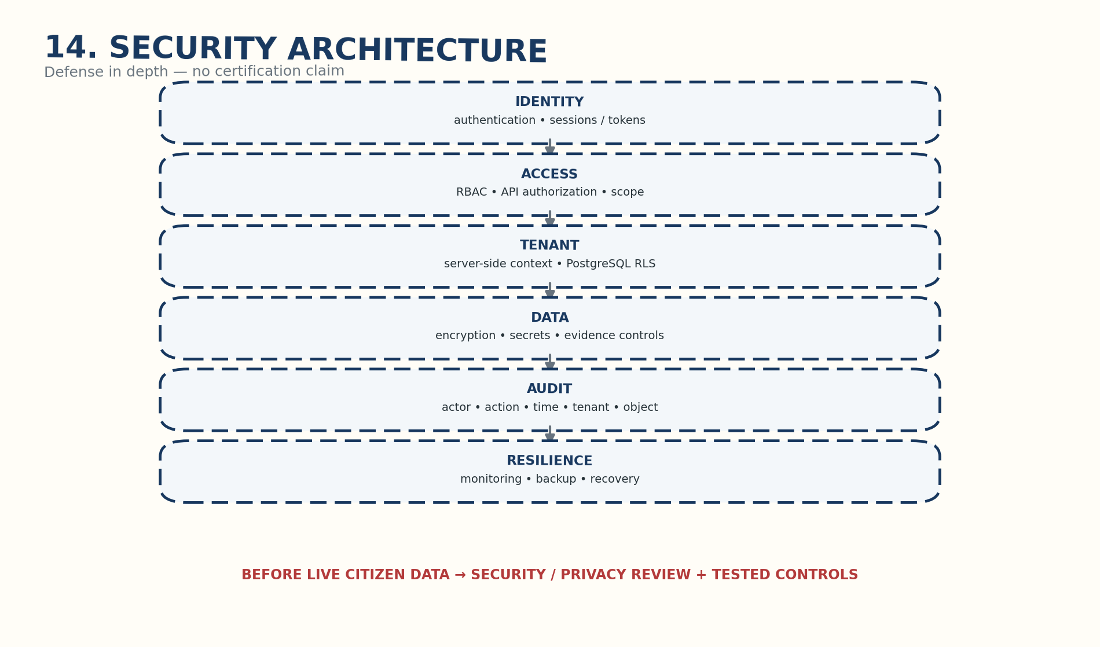
Defense in depth.
- Authentication establishes identity.
- Authorization controls permitted actions and scope.
- Tenant isolation must be enforced server-side and at PostgreSQL RLS.
- Secrets must never be hardcoded.
- Evidence/file access must respect tenant and role scope.
- Independent security/privacy review should precede live citizen data.

20. Notification Architecture
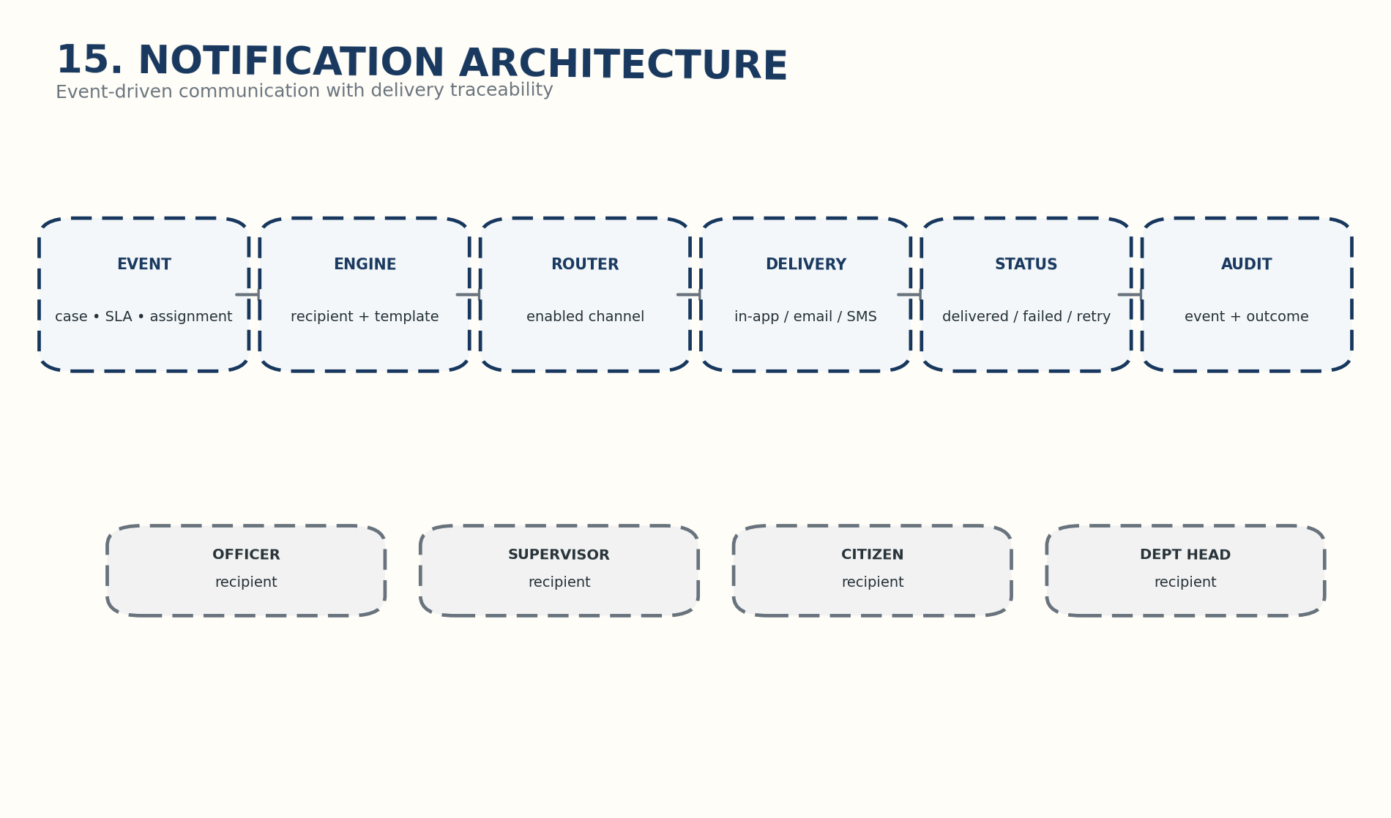
Event → recipient → channel → delivery → audit.
SMS, email, messaging and other external channels are configurable integrations; their availability must be confirmed for the deployment.

21. Dashboard Information Architecture
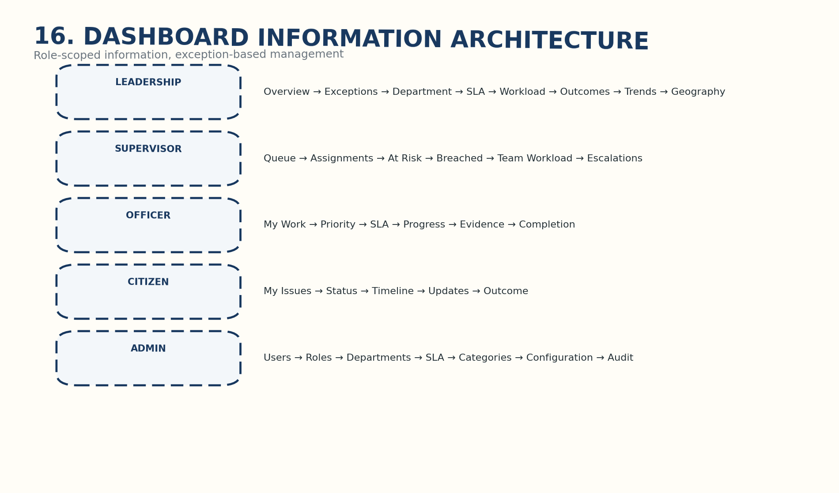
Role-scoped dashboard hierarchy.

22. UI / UX Information Architecture
Persona | Navigation
Citizen | Home → Submit Issue → My Issues → Track → Notifications → Profile
Officer | Dashboard → My Work → Case → Progress → Evidence → Complete
Supervisor | Dashboard → Queue → Assignments → SLA → Escalations → Team
Leadership | Command Centre → Exceptions → Performance → Trends → Geography → Reports
Admin | Users → Roles → Departments → SLA → Categories → Configuration → Audit

23. Mobile / Field Operations
Recommended field sequence: Assigned Work → View Location → Start Work → Capture Progress → Capture Evidence → Complete → Submit for Verification.
GPS, NFC, biometrics and similar device capabilities are not mandatory in this blueprint unless separately approved.

24. Reporting & KPI Model
Report family | Examples | Required KPI metadata
Operational | Open/pending/queues | Definition + source + refresh
SLA | At-risk/breached | Clock + threshold
Department | Performance/workload | Scope + denominator
Officer | Assigned/completed/pending | Assignment scope
Citizen service | Cycle time/status | Population + period
Verification | Verified/rejected/reworked | Decision logic
Audit | Critical actions/access | Event definition
Exception | Stalled/breached/reopened | Exception rule
Every KPI should have a metric name, definition, data source, calculation, frequency and responsible role.

25. Implementation Roadmap
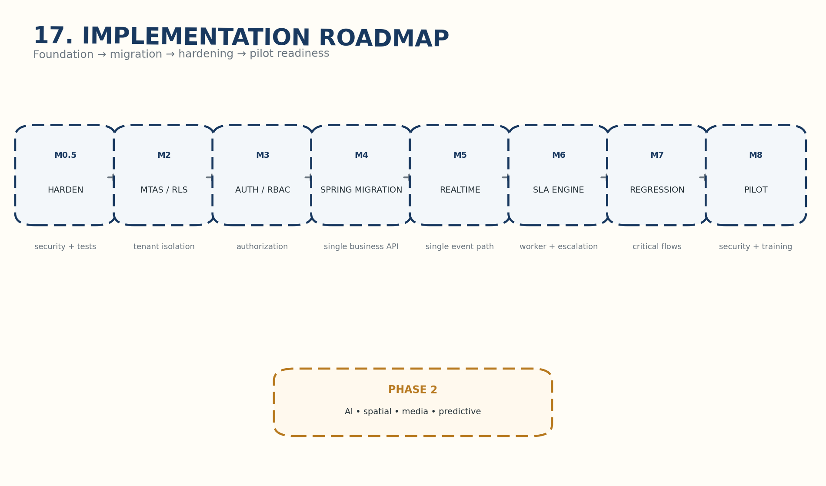
Foundation to pilot-readiness sequence.
Milestone | Focus | Readiness gate
M0.5 | Codebase hardening | Security baseline + tests
M2 | Multi-tenant DB / RLS | Isolation tests pass
M3 | Authentication / RBAC | Authorization tests pass
M4 | Express → Spring | Existing workflows verified on target API
M5 | Realtime | Single event path
M6 | SLA engine | Warnings/breach/escalation verified
M7 | Regression | Critical workflows pass
M8 | Pilot readiness | Security + deployment + training + governance

26. MVP Scope
Priority | Scope
MUST HAVE | Authentication, RBAC, tenant isolation/RLS, citizen issue submission, case lifecycle, assignment, SLA, escalation, completion, verification, closure/reopen, audit, notifications, basic dashboards
SHOULD HAVE | Department workload, GIS foundation, assets, projects, documents/Peshi, richer analytics, field enhancements
FUTURE | AI, media intelligence, predictive governance and advanced intelligence

27. Phase 2 — Intelligence
Phase 2 remains deliberately separated from the Phase 1 pilot: AI-assisted intelligence, GIS/spatial intelligence, media intelligence, advanced analytics and predictive capabilities.
The source explicitly parks real-world video reporting, photo evidence capture, AI issue categorization/media analysis, universal issue intelligence, observation intelligence and predictive governance outside Phase 1.

28. Risks & Controls
Risk | Control
Split-brain backend | Migrate business logic to Spring Boot; keep Express only as controlled fallback.
Cross-tenant leakage | PostgreSQL RLS + server-side tenant context + tests.
Weak authentication | Production OTP/JWT + secret management + abuse/expiry tests.
Passive SLA | Background worker + tested escalation.
Unverified completion | Separate completion and verification.
Duplicate business authorities | Explicit component responsibility model.
Integration dependency | Document system authority and integration boundaries.
Security/privacy | Independent review before live citizen data.
AI scope creep | Phase 2 approval gate.
Weak pilot evidence | Baseline + KPIs + acceptance criteria + evaluation.

29. Final Architecture Principles
Principle | Meaning | Government value
Single ownership | Every work item has an accountable owner. | Accountability
Time-bound execution | SLA and escalation are explicit. | Service discipline
Verified outcomes | Completion and verification are distinct. | Credible reporting
Auditability | Critical actions are recorded. | Traceability
Tenant isolation | Municipal data is separated by design. | Data protection
Exception management | Leadership focuses on risk and delay. | Better decisions
Interoperability | GovOS coexists with authoritative systems. | Avoid duplication
Phase discipline | AI/media intelligence stays outside Phase 1. | Scope control

30. Final Consistency Checklist
- Citizen submission enters the same case/work lifecycle as internal operations.
- Every case has explicit ownership and an auditable assignment record.
- Reassignment is controlled and auditable.
- SLA monitoring is connected to execution and breach escalation.
- Completion is distinct from verification.
- Verification can return work for rework.
- Closed work can be reopened through a controlled transition.
- Leadership reporting distinguishes completed from verified outcomes.
- Tenant isolation exists at application and database layers.
- PostgreSQL remains the system of record.
- Spring Boot remains the authoritative business API.
- NestJS is limited to realtime/event responsibility.
- AI/spatial/media intelligence remains Phase 2.
- External integrations are labelled optional unless confirmed.
- Assumptions requiring government/business validation are not presented as established facts.

Source Discipline & Approval Note
SOURCE-DERIVED = supported by the attached GovOS blueprint. RECOMMENDED = architecture/product recommendation. ASSUMPTION / VALIDATION REQUIRED = must be confirmed by the pilot authority, business owner or implementation team.
This document is a professional project blueprint and planning reference. It is not government approval, procurement authorization, a legal certification or a final departmental SOP.

